**OVERALL AWS CONCEPT’S**

**1.Cloud Computing:**

**What is a client-server model?**

You just learned more about AWS and how almost all of modern computing uses a basic client-server model. Let’s recap what a client-server model is.

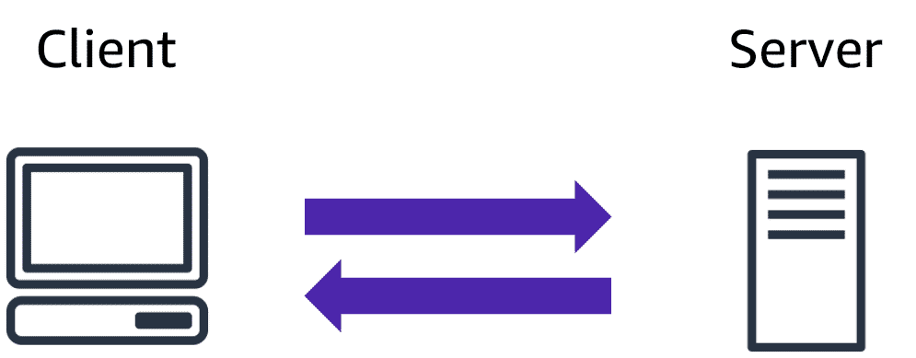

In computing, a**client** can be a web browser or desktop application that a person interacts with to make requests to computer servers. A **server** can be services such as Amazon Elastic Compute Cloud (Amazon EC2), a type of virtual server.

For example, suppose that a client makes a request for a news article, the score in an online game, or a funny video. The server evaluates the details of this request and fulfills it by returning the information to the client.

**Deployment models for cloud computing**

When selecting a cloud strategy, a company must consider factors such as required cloud application components, preferred resource management tools, and any legacy IT infrastructure requirements.

The three cloud computing deployment models are

1.cloud-based,

2.on-premises,

3.and hybrid.

1.cloud-based:

* Run all parts of the application in the cloud.
* Migrate existing applications to the cloud.
* Design and build new applications in the cloud.

In a **cloud-based deployment** model, you can migrate existing applications to the cloud, or you can design and build new applications in the cloud. You can build those applications on low-level infrastructure that requires your IT staff to manage them. Alternatively, you can build them using higher-level services that reduce the management, architecting, and scaling requirements of the core infrastructure.

For example, a company might create an application consisting of virtual servers, databases, and networking components that are fully based in the cloud.

2.on-premises:

* Deploy resources by using virtualization and resource management tools.
* Increase resource utilization by using application management and virtualization technologies.

**On-premises deployment**is also known as a *private cloud* deployment. In this model, resources are deployed on premises by using virtualization and resource management tools.

For example, you might have applications that run on technology that is fully kept in your on-premises data center. Though this model is much like legacy IT infrastructure, its incorporation of application management and virtualization technologies helps to increase resource utilization.

3.hybrid:

* Connect cloud-based resources to on-premises infrastructure.
* Integrate cloud-based resources with legacy IT applications.

In a **hybrid deployment**, cloud-based resources are connected to on-premises infrastructure. You might want to use this approach in a number of situations. For example, you have legacy applications that are better maintained on premises, or government regulations require your business to keep certain records on premises.

For example, suppose that a company wants to use cloud services that can automate batch data processing and analytics. However, the company has several legacy applications that are more suitable on premises and will not be migrated to the cloud. With a hybrid deployment, the company would be able to keep the legacy applications on premises while benefiting from the data and analytics services that run in the cloud.

**Benefits of cloud computing**

Operating in the AWS Cloud offers many benefits over computing in on-premises or hybrid environments.

In this section, you will learn about six advantages of cloud computing:

* Trade upfront expense for variable expense.
* Benefit from massive economies of scale.
* Stop guessing capacity.
* Increase speed and agility.
* Stop spending money running and maintaining data centers.
* Go global in minutes.

**2.Amazon EC2:**

**Amazon Elastic Compute Cloud (Amazon EC2)**

[Amazon Elastic Compute Cloud (Amazon EC2)](https://aws.amazon.com/ec2/) provides secure, resizable compute capacity in the cloud as Amazon EC2 instances.

Imagine you are responsible for the architecture of your company's resources and need to support new websites. With traditional on-premises resources, you have to do the following:

* Spend money upfront to purchase hardware.
* Wait for the servers to be delivered to you.
* Install the servers in your physical data center.
* Make all the necessary configurations.

By comparison, with an Amazon EC2 instance you can use a virtual server to run applications in the AWS Cloud.

* You can provision and launch an Amazon EC2 instance within minutes.
* You can stop using it when you have finished running a workload.
* You pay only for the compute time you use when an instance is running, not when it is stopped or terminated.
* You can save costs by paying only for server capacity that you need or want.
* **Amazon EC2 instance types**
* [Amazon EC2 instance types](https://aws.amazon.com/ec2/instance-types/) are optimized for different tasks. When selecting an instance type, consider the specific needs of your workloads and applications. This might include requirements for compute, memory, or storage capabilities.
* To learn more, select the **+** symbol next to each category.
* **General purpose instances**
* **Compute optimized instances**
* **Memory optimized instances**
* **Accelerated computing instances**
* **Storage optimized instances**

**General purpose instances:**

–

**General purpose instances** provide a balance of compute, memory, and networking resources. You can use them for a variety of workloads, such as:

* application servers
* gaming servers
* backend servers for enterprise applications
* small and medium databases

Suppose that you have an application in which the resource needs for compute, memory, and networking are roughly equivalent. You might consider running it on a general purpose instance because the application does not require optimization in any single resource area.

**Compute optimized instances:**

–

**Compute optimized instances** are ideal for compute-bound applications that benefit from high-performance processors. Like general purpose instances, you can use compute optimized instances for workloads such as web, application, and gaming servers.

However, the difference is compute optimized applications are ideal for high-performance web servers, compute-intensive applications servers, and dedicated gaming servers. You can also use compute optimized instances for batch processing workloads that require processing many transactions in a single group.

**Memory optimized instances:**

–

**Memory optimized instances** are designed to deliver fast performance for workloads that process large datasets in memory. In computing, memory is a temporary storage area. It holds all the data and instructions that a central processing unit (CPU) needs to be able to complete actions. Before a computer program or application is able to run, it is loaded from storage into memory. This preloading process gives the CPU direct access to the computer program.

Suppose that you have a workload that requires large amounts of data to be preloaded before running an application. This scenario might be a high-performance database or a workload that involves performing real-time processing of a large amount of unstructured data. In these types of use cases, consider using a memory optimized instance. Memory optimized instances enable you to run workloads with high memory needs and receive great performance.

**Accelerated computing instances:**

–

**Accelerated computing instances** use hardware accelerators, or coprocessors, to perform some functions more efficiently than is possible in software running on CPUs. Examples of these functions include floating-point number calculations, graphics processing, and data pattern matching.

In computing, a hardware accelerator is a component that can expedite data processing. Accelerated computing instances are ideal for workloads such as graphics applications, game streaming, and application streaming.

**Storage optimized instances:**

–

**Storage optimized instances** are designed for workloads that require high, sequential read and write access to large datasets on local storage. Examples of workloads suitable for storage optimized instances include distributed file systems, data warehousing applications, and high-frequency online transaction processing (OLTP) systems.

In computing, the term input/output operations per second (IOPS) is a metric that measures the performance of a storage device. It indicates how many different input or output operations a device can perform in one second. Storage optimized instances are designed to deliver tens of thousands of low-latency, random IOPS to applications.

**Q & A :.**

* Ideal for high-performance databases🡪 Memory optimized
* Suitable for data warehousing applications🡪 Storage optimized
* Balances compute, memory, and networking resources🡪 General purpose
* Offers high-performance processors🡪 Compute optimized